**Consumers behaviour towards OTT Platforms**

Data Analysis Report :

1)Invest In Making English content

Inference:-

1)People Mostly view the content in English over OTT Platforms

2)Consumers Prefer Hindi,English Content Over Other Languages

Recommendations:-

1)More Profitable when Producer will Make movies in English

2)Increase the Demand of Hindi, Marathi Content by Giving Relevant Adds

3)Increase the Demand of Hindi, Marathi Content by Increase the Quality of Content

4) At Start 1/2 Episodes should available for Free as far as Hindi Content, After that enable Subscription Charges, If they watch starting Episodes and if they like then Consumers may take Subscription for the Content

5)Provide Free Content in Marathi

2) Time spend on OTT

Inference:-

1)Mostly Consumer Spend max 1 to 2 hours on OTT Platforms.

2) There are still some People Who are not on OTT Platforms

Recommendations:-

1)Producer Should invest More on Web Series than that of Movies Because Movies are Generally of 3 Hours and Web Series episodes are Generally of 1 hours Each.

2)Consumer will come to Know about the shows by Giving advertisment on TV, Youtube.

3)Give one month free Subscription, So that After Watching the content on OTT Platforms ,They might like it .

4)we can attract Consumer by organising Some Contest ,By Giving Cash Prices, Gifts ,Free Movies depending upon the Contest

5)We can Slightly increase the time of Episodes by 15/20 min per episode so that people will spend more time on OTT

6) For Attracting more Female Consumers, we Can Give Some Discount Coupons on Subscriptions Generally for shopping from Well-known Markets Such has D-mart, Big Bazaar, Popular Malls etc

7) For enchanting more Male Consumers in these Digital World, We Can Give Some Discount Coupons on Subscriptions Generally for shopping from Flipkart, Amazon So that they can Purchase Respective Electronic Item

8)Another Strategy for charming Male Consumers is by giving advertisment of Products By the Models /Actress.

3) Rise in International Content

Inference:-

1)Increase in International Content Over the Years.

2)Consumers generally Prefer Hindi under national Content.

4) Overpriced Subscription

Inference:-

1) In Non Metropolitan Cities ,Consumers mainly Prefer Free content ,Paid Content is less in case of Metropolitan Cities

Recommendations:-

1) So Producer should mainly focus on Creating Free Content

2) If Subscription Charges can be Reduce then there is a chances of Increase in Viewership in Non-metropolitan Cities

5) Months of Subscription

Inference:-

1)Consumer generally Preferred one month Subscription or More than 4.

Recommendations:-

1) One Way to increase the Consumers on OTT is Reducing little Cost of Subscription for between 2-4 Months.

2) Consumers should get Some Discount Offers on Subscription

3)Also there are Some People who don't take Subscription ,So Creating Good Content By understanding Todays Trends will help to enchant more users.

6) Mobile Viewers are uplifted

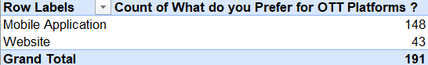

Inference:-

Mobile Application Users are more than that of website.

Recommendation:-

It notifies that Producer should focus more on investment of advertisment in Mobile Application.

7) Youth spend max time on OTT

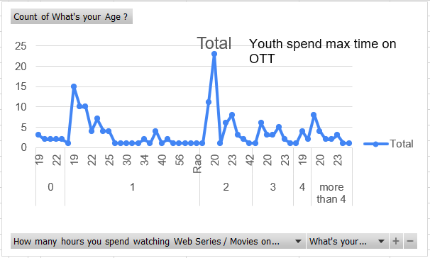Inference:-

1)Consumer who watch movies atleast for 1 hours are within age grp between 25 to 40, it Generally tells you Consumers are working people.

2)More than 1 hours viewers are young mainly in age grp of 19 to 20.

8) Demand of OTT is High

Inference:

1) Most of the Consumers Prefer OTT platforms rather than TV.

Recommendations:

1)By making the Subscription charges less than TV Cable Connection charges, it will help to increase the Consumers on OTT.